# C2- S4-PRACTICE

*NOTE: check your* ***THEORY slides*** *to answer those questions!*

# EXERCISE 1 – BOOK & AUTHORS

We want to manage books and authors:

* A book has always 1 author only
* An author could write many books.

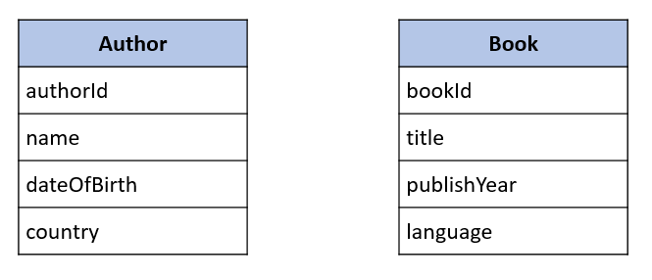

**Q1** – What is the relation between Book and Author tables?

The relation between book and author table is one to many.

* + Complete the missing attributes or table to allow this relation

many

1

|  |
| --- |
| Author |
| Author Id |
| Name |
| Date Of Birth |
| Country |
|  |

|  |
| --- |
| Book |
| Book Id |
| Title |
| Publish Year |
| language |
| Author Id |

**Q2** – For each table, complete the following arrays, by specifying for each attribute:

* + The field type (SQL type) and size
  + Can be null or not?
  + Is a primary key or foreign keys?

**AUTHOR TABLE**

|  |  |  |  |
| --- | --- | --- | --- |
| Attribute name | Type / size | Can be Null? | Key |
| Author ID | Int | No | PK |
| Name | Varchar (20) | Null |  |
| age | Varchar (3) | Null |  |

**BOOK TABLE**

|  |  |  |  |
| --- | --- | --- | --- |
| Attribute name | Type / size | Can be Null? | Key |
| Book Id | Int | No | PK |
| Title | Varchar (50) | Null |  |
| Publish year | Date | Null |  |

**Q3** – Write the SQL statement to create the 2 tables with appropriate properties

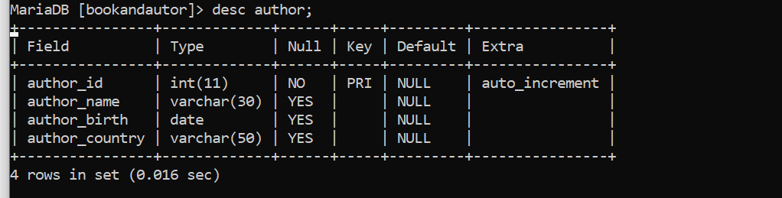

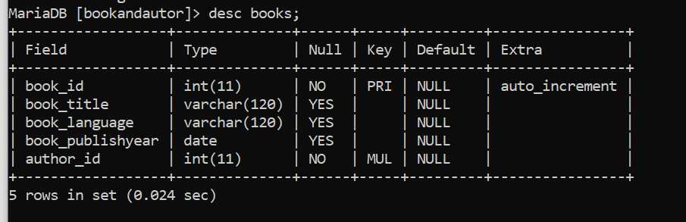

**Q4–** Write the statement to insert 5 books and 5 authors

* + Find the book and author information on the Internet
  + 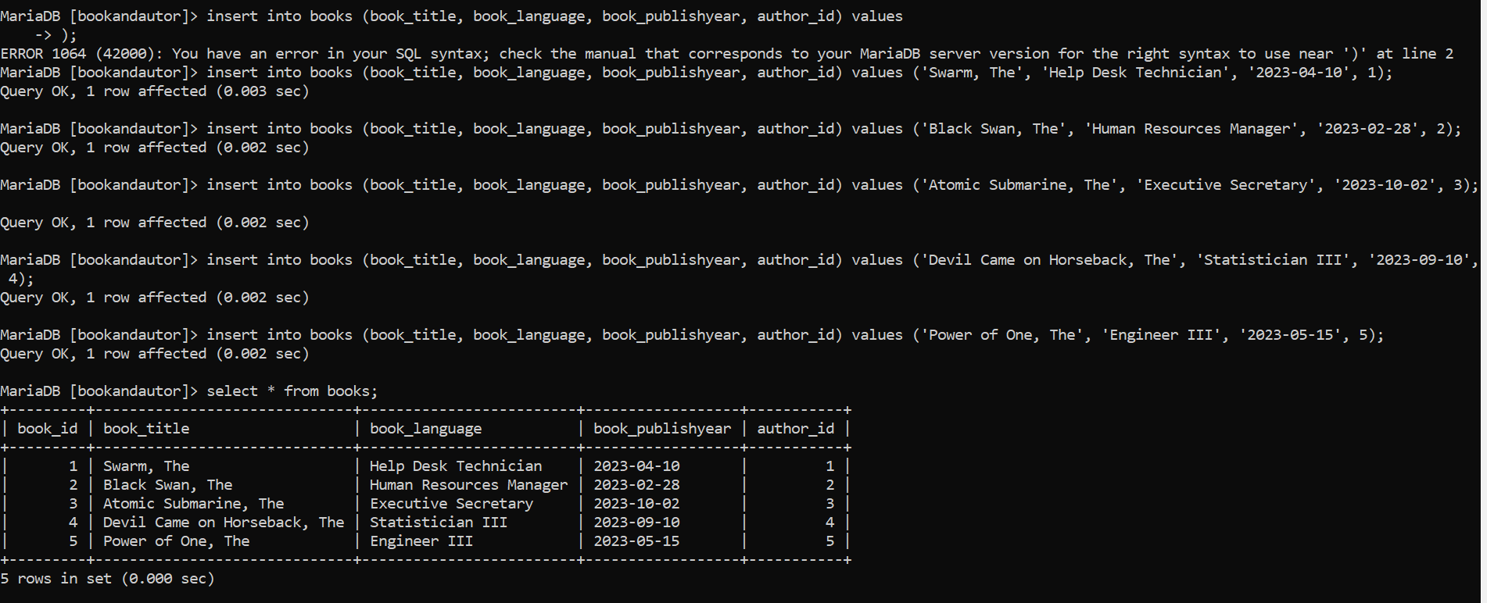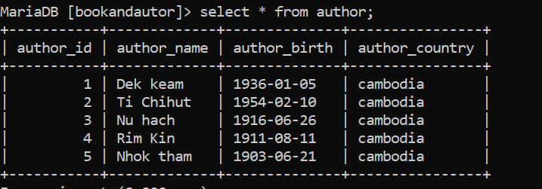

**Q5–** Write the SQL statement to **delete 3 of your books** from the database

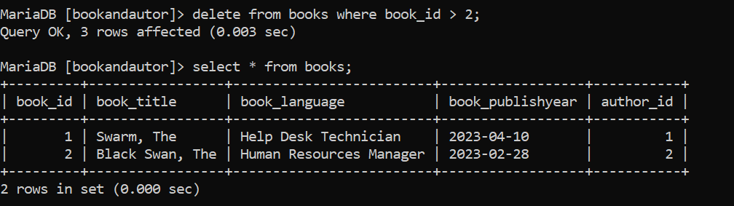

# EXERCISE 2 – USERS & POSTS

We want to manage **users** and **posts** (like posts on Facebook)

* A post is related to **1 user only**
  + A post has a body (the text of the post)
* User can have **many posts**
  + A user has a first name, and a nick name (optional)

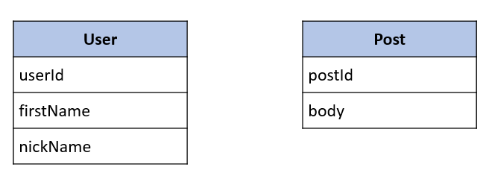

**Q1** – What is the relation between User and Post Table?

The relation between User and Post is One to many.

|  |
| --- |
| Post |
| Post id |
| Post body |
| Post publish year |
| User id |

* + Complete the missing attributes or table to allow this relation

|  |
| --- |
| User |
| User id |
| First name |
| Last name |

1

many

**Q2** – For each table, complete the following arrays, by specifying for each attribute:

* + The attribute type (SQL type) and size
  + Can be null or not?
  + Is a primary key or foreign keys?

**USER TABLE**

|  |  |  |  |
| --- | --- | --- | --- |
| Attribute name | Type / size | Null? | Key |
| User id | Int | No | PK |
| User name | Varchar(50) | Null |  |
| User gender | Varchar(10) | Null |  |

**POST TABLE**

|  |  |  |  |
| --- | --- | --- | --- |
| Attribute name | Type / size | Null? | Key |
| Post id | Int | No | PK |
| Post name | Varchar(50) | Null |  |
| Date | Date | Null |  |

**Q3** – Write the SQL statement to create the 2 tables with appropriate properties

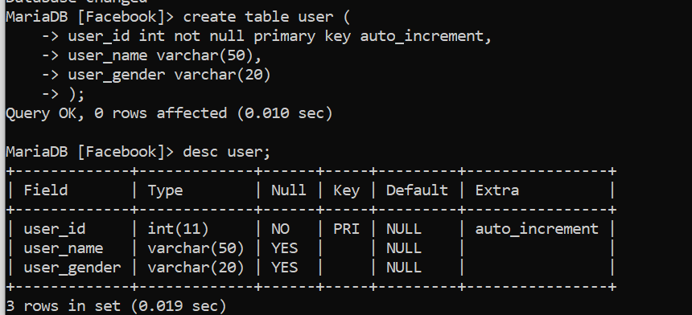

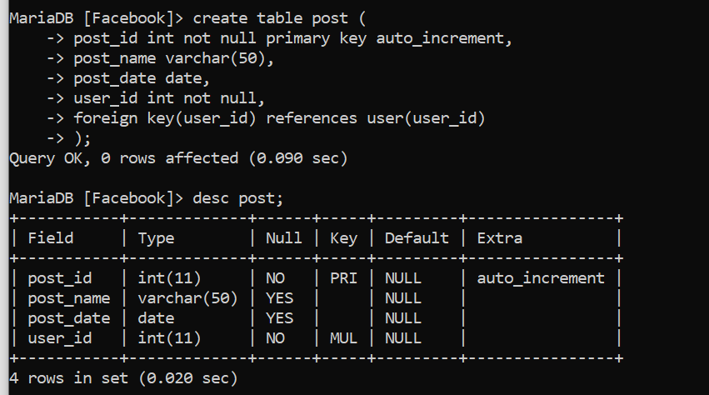

**Q4–** Write the statement to insert the following users and posts

Notes:

* ---- means: no value (the nickname is optional!)
* We don’t specify the KEY, it’s your business!

**USERS**

|  |  |
| --- | --- |
| First name | Nick name |
| Ronan | roro |
| Sokea | ---- |
| Edouard | doudou |

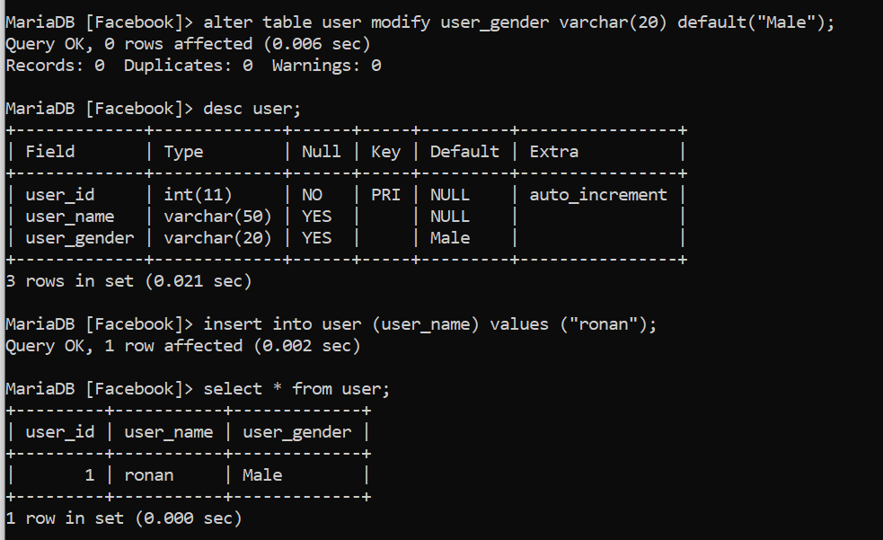

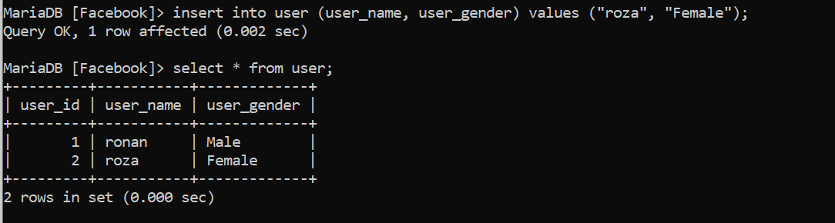

**POSTS**

|  |  |
| --- | --- |
| Post body | From |
| Hello all ! | Ronan |
| I like rice | Ronan |
| YES YES | Sokea |

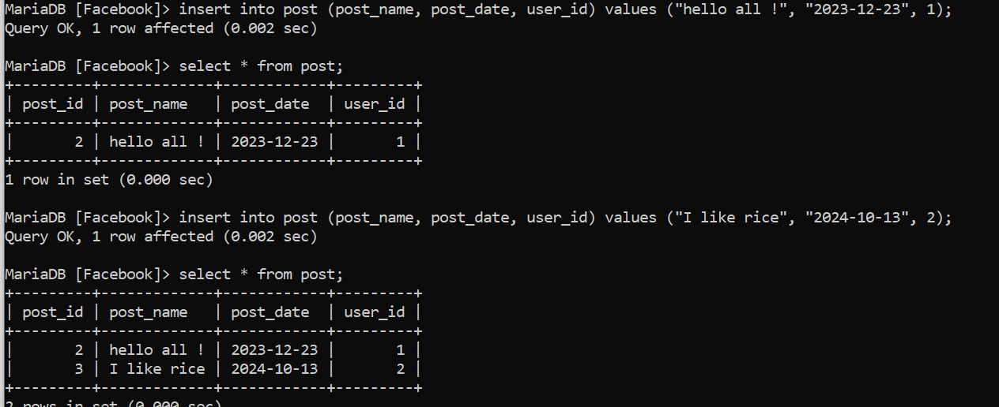

**Q5–** Write the statement to delete the user Edouard

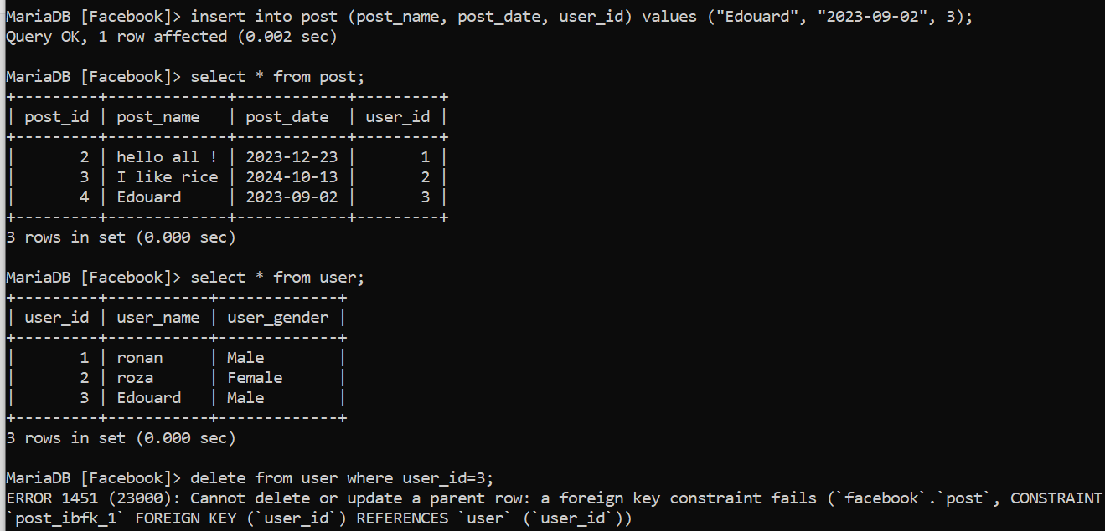

* What’s happen? Can we delete it? Why?

We can’t delete it . Because is a parent row and it is a foreign in a post table.

**Q6–** Write the statement to delete the user Ronan

* What’s happen? Can we delete it? Why?
* We can’t delete it . Because is a parent row and it is a foreign in a another table.

**Q7–** Write SQL statement to remove the rows related to Ronan user:

* We can’t delete it. Because it is a foreign in a another table.
* Hello all!
* I like rice

**Q8–** now try again to delete the user Ronan

* What’s happen? Can we delete it? What can you conclude?
* We can delete it. Because we already delete it on another table.

**Q9–** Add a new POST in the POST table with a userId which does not exist in the User table (ex: 45)

* What’s happen? Why?
* We can’t add it . Because user_id which we want to add doesn’t have in user table.